MAP PROJECT

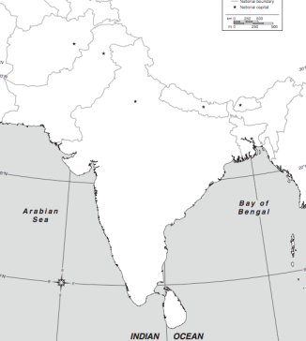 With your group you will make a photographic map of the region of South Asia to better understand what the region looks like.

REQUIREMENTS:
- Draw a map of the region on butcher paper
  - Label the Indian Ocean, Arabian Sea, Bay of Bengal and each country (page 591)
  - Draw and label these rivers: Indus, Ganges, Brahmaputra
- Find illustrations of vegetation and physical features in National Geographic, cut them out and glue to the map in the correct place!
  - Vegetation/ecosystems, page 597
  - Physical features, page 593
- Draw the monsoon winds, color the climates, p 595
  - Make a KEY!
- Put your names on the back of the map!
- You will be sharing your map

