Monsoons & Climate graph

On the maps below draw the monsoon winds according to the label. Draw the summer monsoon arrows red and the winter monsoon arrows blue! . Reference maps on pages 626 and 595.

SUMMER MONSOONS WINTER MONSOONS

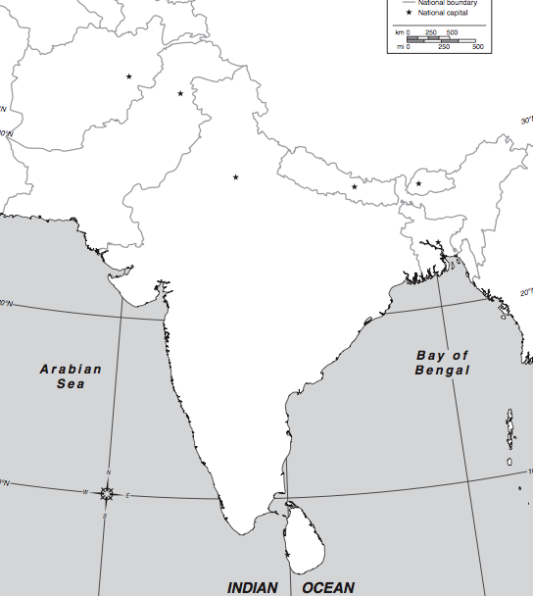

On both maps label: Cherrapunji Himalaya mountains

- Which monsoon winds are likely to bring wet weather? ______________
- Which monsoon winds are likely to bring drier weather? _____________
  - Why? __________________________________________________
- The southwest coast of India has a wet tropical rain forest or tropical savanna climate while the southern interior of India has a dry steppe climate. Why? ___________________________________________________________________________
___________________________________________________________________________

Next, make a climate graph for Cherrapunji, India. The data is provided. Remember to label the left side for temperature in Fahrenheit, and the right side for rainfall in inches.
Cherrapunji, India
25°N, 91°E; 4,308’ above sea level
J F M A M J J A S O N D

Average Temperature & Rainfall – Cherrpunji, India
 | J | F | M | A | M | J | J | A | S | O | N | D
°F | 49 | 53 | 61 | 66 | 67 | 69 | 70 | 69 | 68 | 63 | 56 | 51
Inches | 0.5 | 0.9 | 2.1 | 5 | 11 | 18 | 14 | 13 | 13 | 7 | 1.3 | 0.2
- Which months are the summer monsoons? ___________________________________
- How do you know? __________________________________________________________
_____________________________________________________________________________
On the map below, color the climates and make a key. (Look at p595)

