Travel with us!
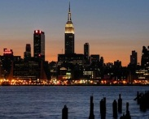

A paragraph about the country that make me want to go there!
Sites…
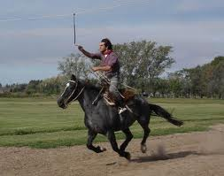
Describe the photos

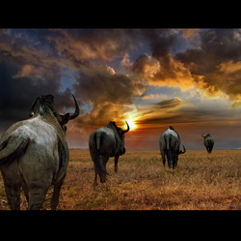
What to expect
Flight?

Hotels?

Meals?

Activities?

Team Members
Sam Smith
Bob Barker
Charles Cookie
Frank Footsy
Period 9
France

Land of Romance!

