Diary of Anna Green Winslow (1772)
Anna Green Winslow (29 November 1759 – 19 July 1780), of Boston, Massachusetts, United States, was a girl who wrote a series of letters to her mother between 1771 and 1773 that portray the daily life of the a more wealthy child in Boston. These are entries from the year 1772
January 4 I was dressed in my yellow coat, my black bib & apron, my shoes, the cap my Aunt Storer presented me with (blue ribbons on it) & a very handsome locket in the shape of a heart she gave me. And I would tell you that for the first time they all liked my dress very much.
January 11 I have attended my school every day this week except Wednesday afternoon. I made a visit to Aunt Suky, & was dressed just as I was to go to the ball. I heard Mr. Thacher preach our lecture last evening. I remember a great deal of the sermon, but don't have time to put it down.
February 9 I am disabled by a sore on my fourth finger & something like one on my middle finger from using my own pens. But altho' my right hand is in bandages, my left is free. My aunt says it will be a nice opportunity when it improves to learn to spin flax. I am pleased with the proposal & aim at present to exert myself for this purpose. I hope, when
two or at most three months are past, to give you a visible demonstration of my skill in this art, as well as several others. I have read my Bible to my aunt this morning (as is the daily custom) & sometimes I read other books to her.
February 21 My Grandmamma sent Miss Deming, Miss Winslow, & I one eighth of a dollar apiece for a New Year's gift. I have made the purchase I told you of a few pages ago, that is, last Thursday I purchased with my aunt Deming's leave a very beautiful white feather hat. I have long been saving my money to buy this hat.
February 22 I have spun 30 knots of linen and mended a pair of stockings for Lucinda, read a part of the Pilgrim's Progress, copied part of my text journal. Played some, laugh'd enough, & I tell aunt it is all human nature, if not human reason.

‘City upon a Hill’
(Modified)

Source: John Winthrop (1588–1649), lawyer and leader of the 1630 migration of English Puritans to Massachusetts Bay Colony, delivered this famous sermon aboard the ship Arbella to settlers traveling to New England.

The only way to provide for our posterity is to do justly, to love mercy, and to walk humbly with our God. We must be knit together in this work as one man; we must take care of each other with brotherly affection.
We shall be united in the bond of peace, the Lord will be our God and delight to dwell among us, so that we shall see much more of his wisdom, power, goodness and truth.
We shall be as a City upon a Hill, the eyes of all people are upon us; so that if we shall [behave badly] and cause God to withdraw his help from us, we shall [invite] the mouths of enemies to speak evil of the ways of God, and cause their prayers to be turned into curses upon us.
Therefore let us choose life, that we, and our [children], may live; by obeying his voice, for he is our life, and our prosperity.

Vocabulary:
Posterity: future generations Prosperity: wealth

Report on Pennsylvania
William Penn acquired Pennsylvania as a haven for his fellow Quakers. But the colony was not exclusively reserved for Quakers. As Penn intended, people of various nations and faiths settled there. In 1685 Penn published a book about his colony, called A Further Account of the Province of Pennsylvania. Here is a part of his account.
The people are a collection of different nations in Europe, such as French, Dutch, Germans, Swedes, Danes, Finns, Scots, Irish, and English. But as they are of one kind and in one place and under one allegiance, so they live like people of one country....
Philadelphia is two miles long and a mile broad and at each end it lies a mile upon a navigable river. Besides the High Street that runs in the middle, it has eight streets more that run the same course. And besides Broad Street, which crosses the town in the middle, there are twenty streets more that run the same course....
During the first ten months since our arrival we had got up 80 houses at our town, and some villages were settled about it. During the next year the town advanced to 357 houses. Many of them were large and well-built, with good cellars and three stories. Some had balconies.
There is also a fair wharf of about three hundred square feet. ...
There lived most sorts of useful tradespeople such as carpenters, bricklayers, masons, plasterers, plumbers, smiths, glaziers, tailors, shoemakers, butchers, bakers, tanners, shipwrights....
The hours for work and meals to laborers are fixed and known by ring of bell....
Some vessels have been built here and many boats, which are useful for passage of people and goods...
With the natives we live in great friendship. I have made seven purchases. And in pay and presents they have received at least twelve hundred pounds [English units of money] of me.
They generally leave their guns at home when they come to our settlement. They offer us no insult, not so much as to one of our dogs. If any of them break our laws, they submit to be punished by them.
We leave not the least wrong done to them unsatisfied. Justice gains and awes them. They have some great people among them, I mean for wisdom, truth, and justice.

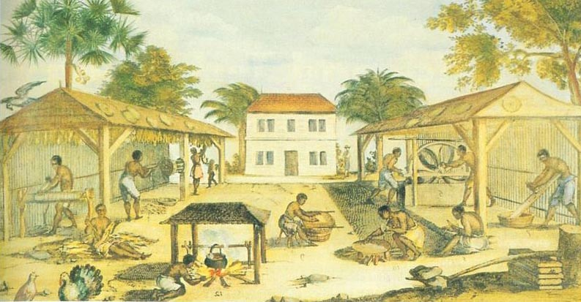

Virginia 1670 Slaves Processing Tobacco
Artist is Unknown

http://www.learnnc.org/lp/multimedia/8850

